TIFF URL Viewer
Pluggable widget for Mendix Studio Pro 10.24.17
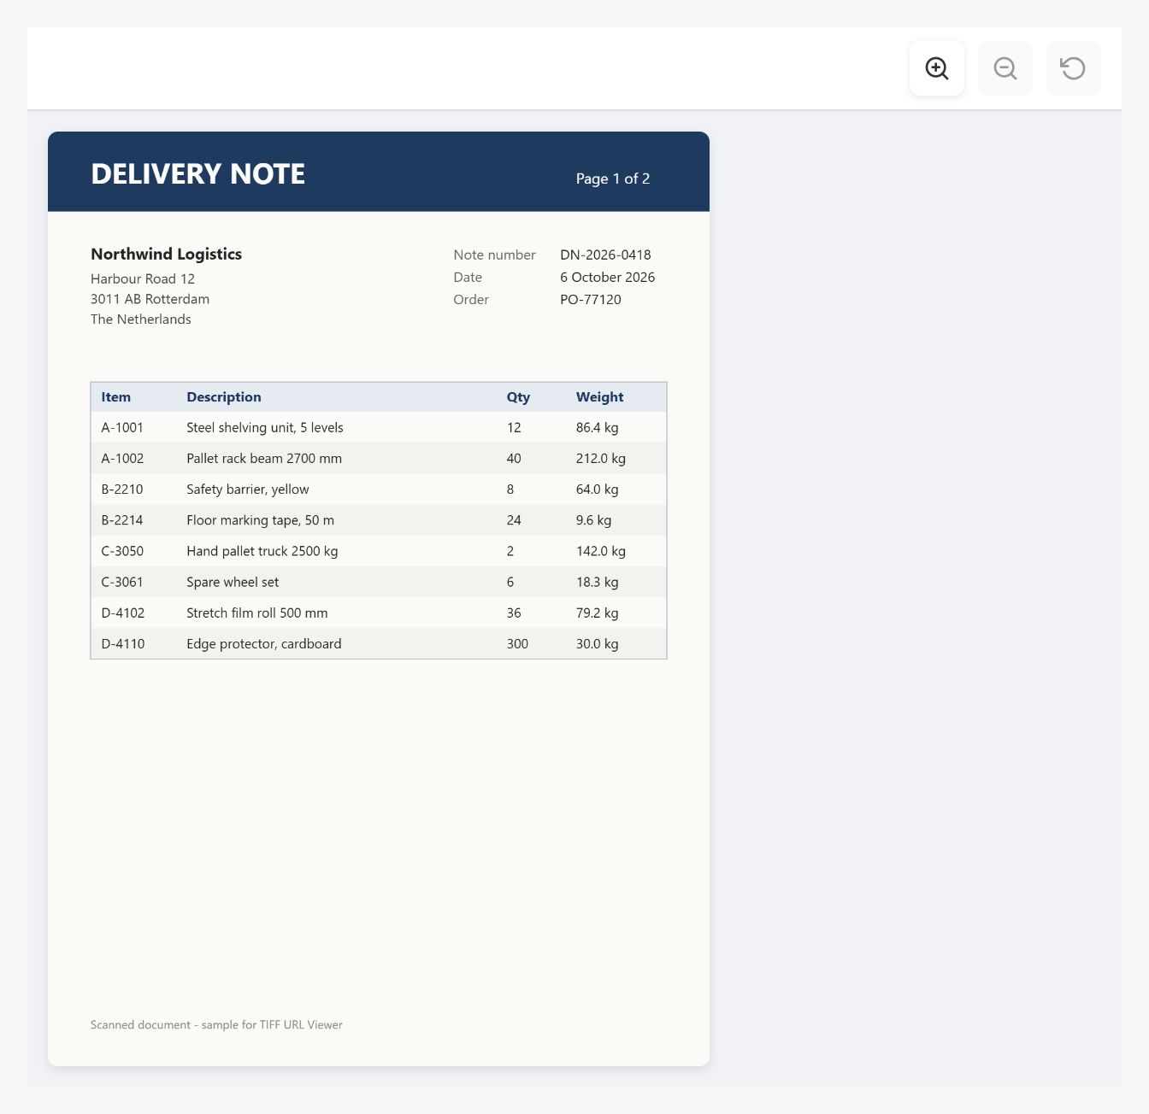
Figure 1. A scanned two-page delivery note with the zoom buttons
Item | Value
Widget version | 1.1.0
Studio Pro version | 10.24.17 (tested on 10.24.17.102810)
Widget ID | mendix.tiffurlviewer.TiffURLViewer
Widget package | mendix.TiffURLViewer.mpk (about 96 KB)
Platform | Web (offline capable)
TIFF library | utif2 4.1.0
Build tooling | @mendix/pluggable-widgets-tools 10.16.0
Source and downloads | github.com/bharathidas/TIFF-URL-Viewer

Contents

1. Overview
Browsers cannot show TIFF images in an image widget. TIFF URL Viewer loads a TIFF file from a URL, decodes it in the browser and shows every page of the file below each other. The pages are scaled to fit the box, and optional Zoom in, Zoom out and Reset buttons let the user look at the details.
The URL comes from a String attribute, for example the URL of a Mendix file document (/file?guid=…) or a file on another server. The width, height and the zoom buttons also come from attributes, so they can change at run time.

Typical uses
- Scanned documents such as delivery notes, invoices, contracts and forms
- Faxes, which are usually stored as multi-page TIFF files
- Technical drawings, plans and medical or archive images in TIFF format
- Previewing an uploaded TIFF file before it is processed

2. What is new in version 1.1.0
- Rebuilt for Mendix Studio Pro 10.24.17 with @mendix/pluggable-widgets-tools 10.16.0 and utif2 4.1.0, as a production build. The package is about 96 KB; version 1.0.0 was about 1.6 MB per bundle because it contained the whole Feather icon set.
- An empty Width or Height attribute now uses 600px, as the description says. In 1.0.0 the box filled the page width and grew to the height of the image.
- A number without a unit (for example 400) is read as pixels. In 1.0.0 it was ignored.
- The page fits the box: the padding and the zoom toolbar are taken into account, so a fitted page has no scroll bars. The fit is calculated again when the box changes size, for example with a percentage width.
- On a phone the box is never wider than the screen.
- TIFF files on another server work when that server allows CORS. 1.0.0 always sent cookies, and browsers block that when the server answers Access-Control-Allow-Origin: *. Cookies are still sent to your own app, so Mendix file documents keep working.
- Clear error messages: The file is not a valid TIFF image. for other files, and the HTTP status (for example 404) when the file cannot be loaded. In 1.0.0 a non-TIFF file showed an empty box.
- Clearing the URL removes the old image, and a new URL no longer shows the previous image while it loads.
- Reduced-resolution thumbnails stored inside a TIFF are no longer shown as an extra page.
- Only the guid is kept from Mendix file URLs (/file?guid=…); other URLs are fetched unchanged. In 1.0.0 every URL with a guid parameter lost its other parameters.
- The toolbar stays visible when a zoomed page is scrolled sideways. The buttons have accessible labels, and Zoom in is disabled at the maximum zoom (5x).
- The class and style set in Studio Pro are applied. In 1.0.0 they were ignored.
- No messages in the browser console.
- Studio Pro design mode shows a placeholder instead of trying to load the attribute name as a URL. Clearer captions and descriptions. The widget ID and property keys are unchanged, so existing pages keep their settings.
Version 1.1.0 was tested in a Mendix 10.24.17 app with 27 automated checks; version 1.0.0 fails 13 of them. The checks cover single and multi-page files, thumbnails, the default and custom sizes (px, %, rem), fitting, zoom in, zoom out and reset, the toolbar while scrolling, a non-TIFF file, a missing file, clearing the URL, a file on another server with CORS, a 2400 x 3200 page, class and style, and a phone-sized window. The screenshots in this document are from that test app.

3. Requirements
- Mendix Studio Pro 10.24.17 or a later 10.24 version.
- A web profile. The widget is not available for native mobile.
- The widget must be inside a data view (or another widget that gives an object). The object needs a String attribute with the URL of the TIFF file. No other modules are needed.
- A file on another server must be reachable from the browser of the user and that server must allow CORS for your app.

4. Installation

4.1 Install the widget
- Download mendix.TiffURLViewer.mpk from the Mendix Marketplace or from the GitHub release Version1.1.0.
- Copy the file into the widgets folder of your app. To find the folder, use App > Show App Directory in Explorer in Studio Pro.
- In Studio Pro, choose App > Synchronize App Directory (F4).
- The widget appears in the Toolbox as TIFF URL Viewer (category Display).

4.2 Upgrade from version 1.0.0
- Replace mendix.TiffURLViewer.mpk in the widgets folder with the 1.1.0 file.
- Synchronize the app directory (F4).
- If Studio Pro reports that the widget definition has changed, right-click the error and choose Update all widgets. Your settings are kept.
- If the running app still shows the old widget, stop it, choose App > Clean Deployment Directory, and run it again.
Check after upgrading: if a Width or Height attribute is empty, the viewer is now 600px instead of the full page width. Put 100% in the Width attribute to keep the old width.

5. Configuration

5.1 Show a TIFF file document
A file document (System.FileDocument or a specialization) can be shown with its download URL. The URL has the form /file?guid=<the GUID of the object>.
- Add a String attribute for the URL to an entity, for example TiffUrl on a non-persistent entity TiffViewerHelper, or on your file document entity itself.
- In the microflow or nanoflow that opens the page, get the GUID of the file document (microflow: Java action getGUID from Community Commons; nanoflow: JavaScript action GetGuid from Nanoflow Commons) and set the attribute to '/file?guid=' + $Guid.
- Put a data view on the page with that object.
- Drag TIFF URL Viewer from the Toolbox into the data view.
- On the General tab, select the TIFF URL attribute.
- Optional: select attributes for Width and Height (String) and Show zoom controls (Boolean).
The user must be allowed to read the file document (entity access), otherwise the server answers 401 or 404 and the widget shows the HTTP status.

5.2 Show a file from another server
Put the full URL (for example https://files.example.com/scans/note-0418.tif) in the String attribute. The browser loads the file directly, so the server must allow CORS for the URL of your app (Access-Control-Allow-Origin). No cookies are sent to other servers. When the server does not allow CORS, the widget shows: The TIFF file could not be loaded. Check the URL and, for another server, its CORS settings.

5.3 Recommended settings
Use | Settings
Document preview on a detail page | Width 100%, height 700px, zoom controls true
Small preview in a list or card | Width 240, height 320, zoom controls false
Full-screen review in a pop-up | Width 100%, height 80vh, zoom controls true
Phone | Width 100%, height 70vh

Width, Height and Show zoom controls are attributes, not fixed values. Give them a default value in the domain model (for example 100%, 600px and true) or set them in the microflow or nanoflow that creates the object.

6. Property reference

General
Property | Type | Description (default)
TIFF URL | String attribute | URL of the TIFF file: a Mendix file document URL (/file?guid=…), a relative URL in your app or a URL on another server that allows CORS. Required. Empty = nothing is shown.
Width | String attribute | CSS width, for example 600px, 100% or 40rem. A number without a unit is read as pixels. Empty = 600px. The box is never wider than its container.
Height | String attribute | CSS height, for example 600px or 80vh. A number without a unit is read as pixels. Empty = 600px.
Show zoom controls | Boolean attribute | True shows the Zoom in, Zoom out and Reset buttons above the pages. Empty or false hides them.

Common and Visibility
Property | Type | Description
Name | System | Name of the widget; also gives the class mx-name-<name>.
Class and Style | System | Applied to the outer box of the widget.
Visibility | System | Default or Conditionally.

Zoom
Button | Action
Zoom in | Makes the pages 1.2 times larger, up to 5 times the fitted size.
Zoom out | Makes the pages 1.2 times smaller, down to the fitted size.
Reset | Returns to the fitted size.

A new file starts at the fitted size: the widest and the tallest page fit in the box. When the pages are larger than the box after zooming, the box scrolls.

7. Examples
Figure 2. Width 640, height 620, zoom controls on: the first page fits the box
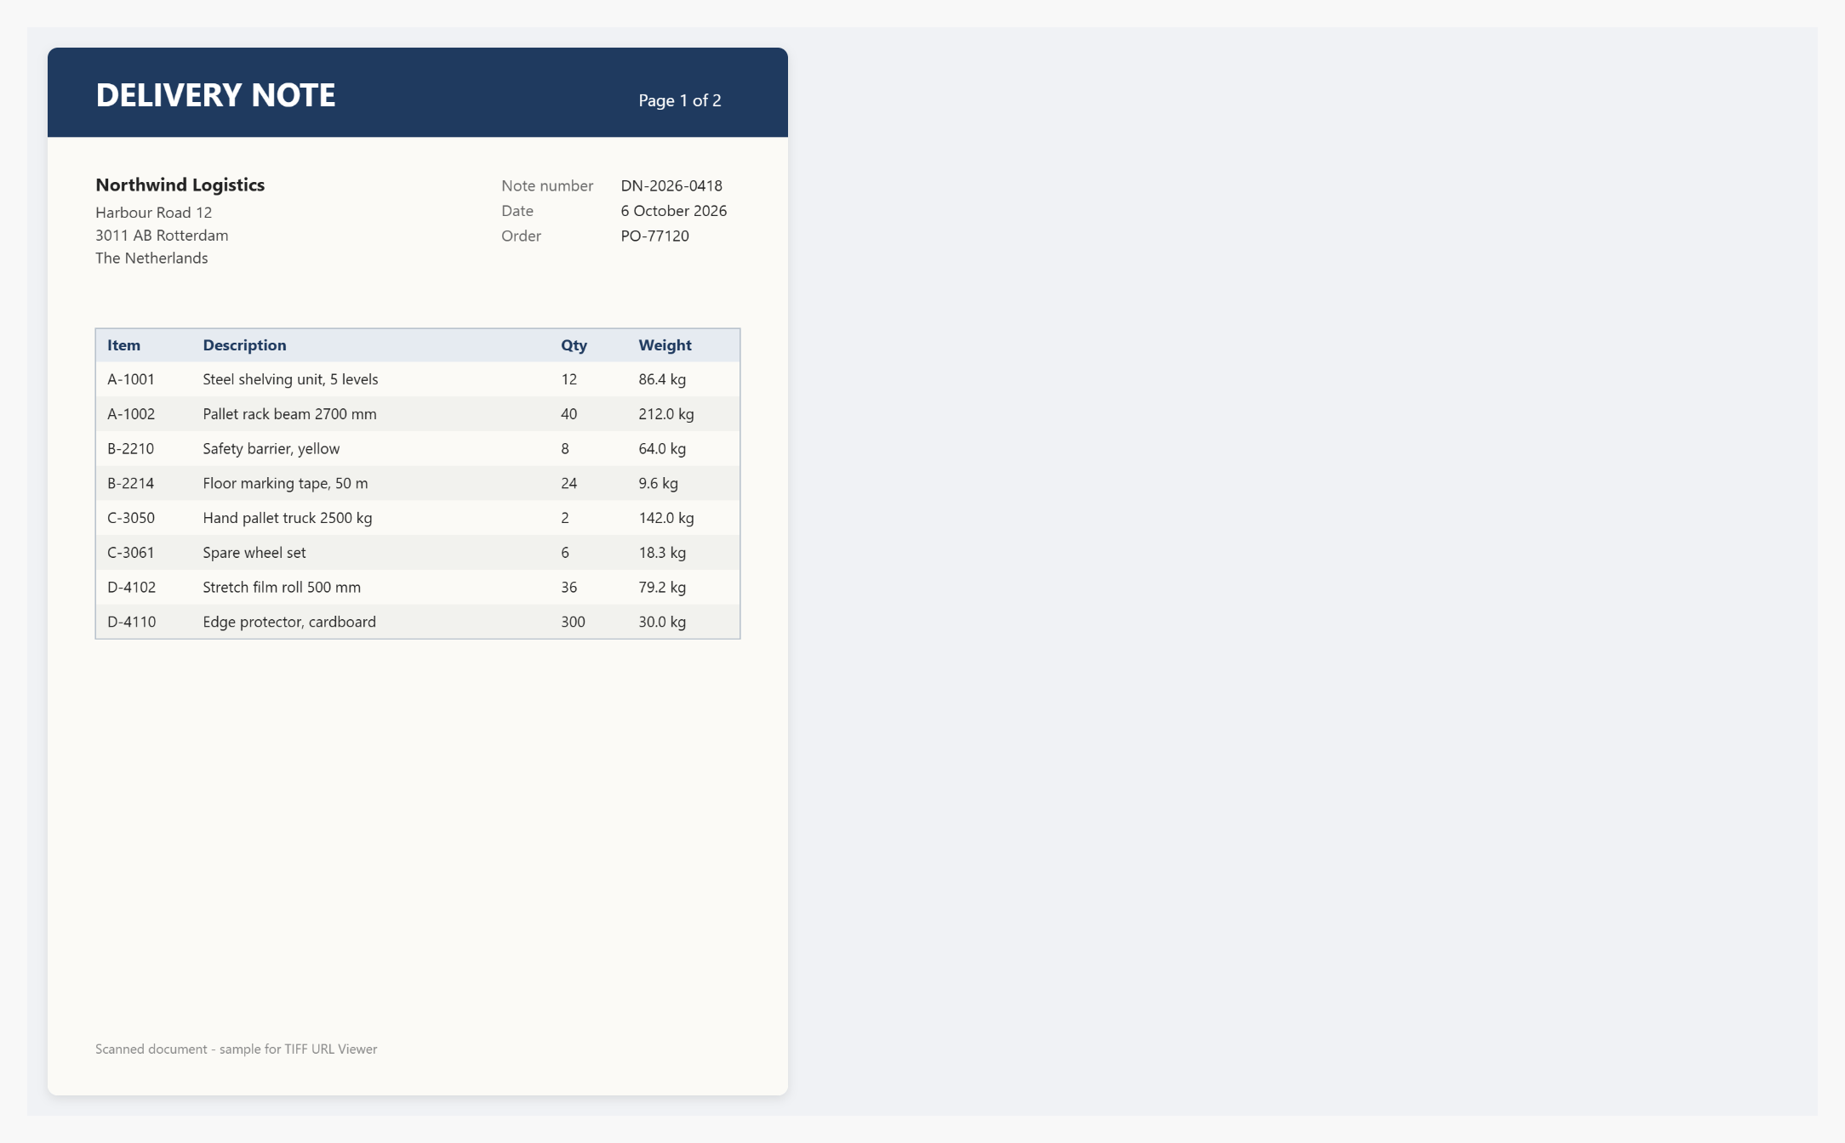
Figure 3. Width 100%, height 640, zoom controls off
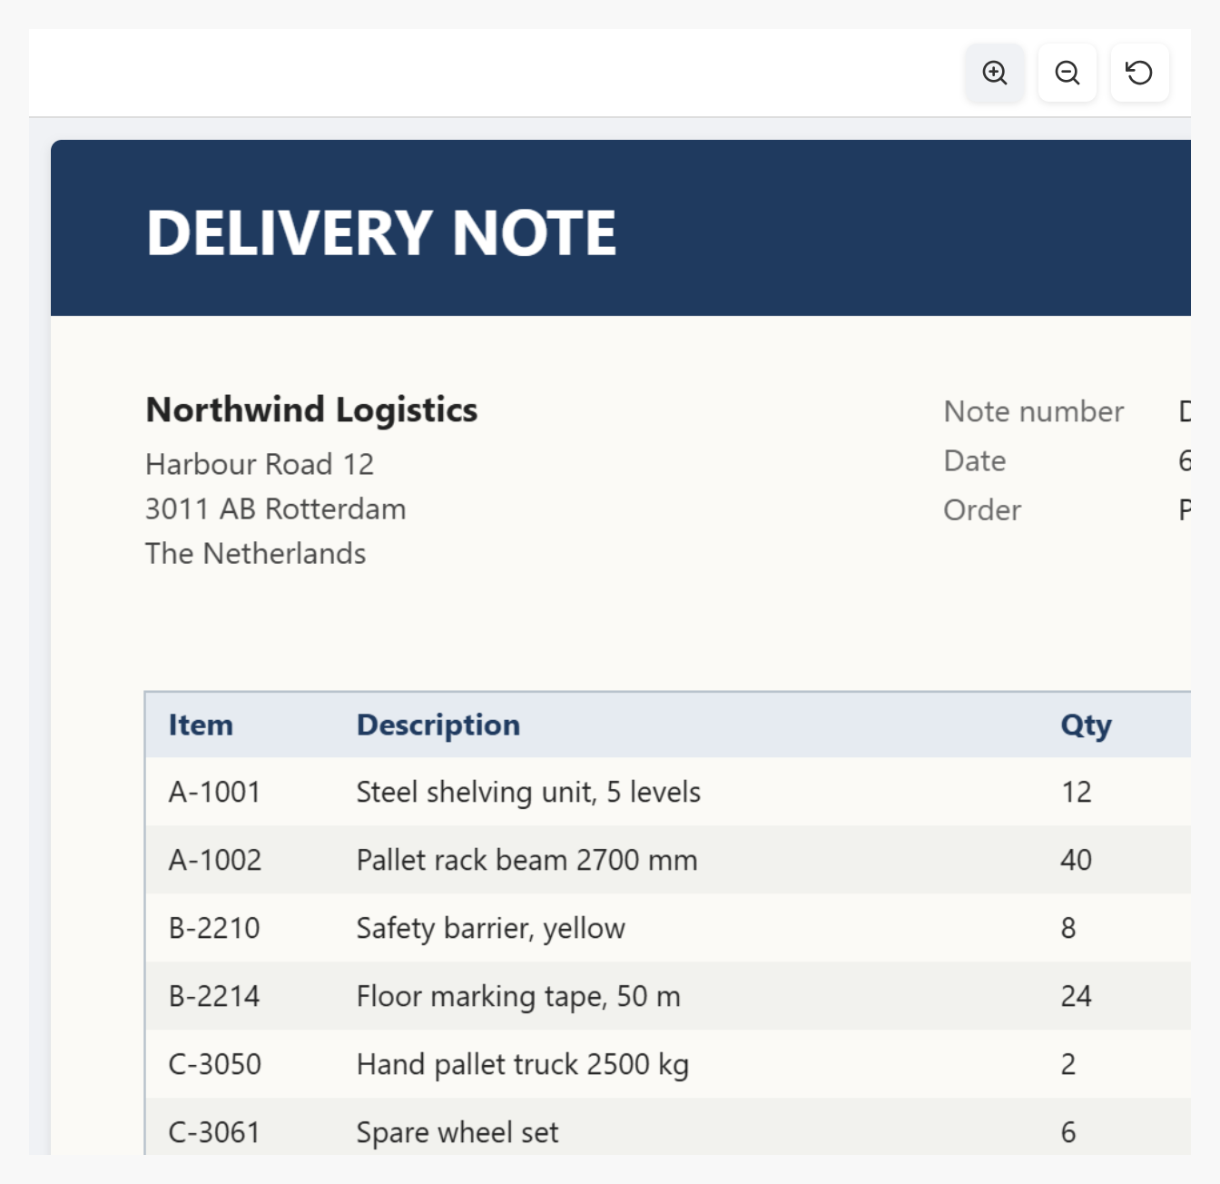
Figure 4. After Zoom in four times: the box scrolls and the toolbar stays in place

Figure 5. A file that is not a TIFF image shows an error message
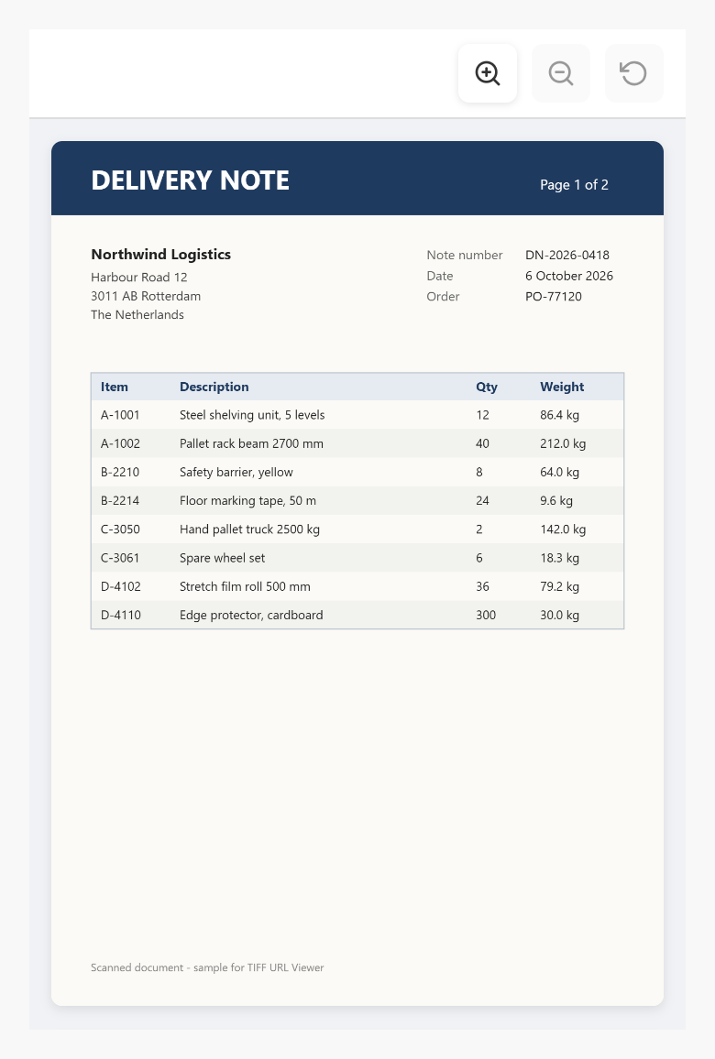
Figure 6. Phone width with width 100% and height 70vh

8. Styling
The widget renders these elements. The class and style from Studio Pro are applied to the outer element.
<div class="widget-tiffurlviewer mx-name-tiffURLViewer1 your-class">
<div class="widget-tiffurlviewer-toolbar">
<button class="widget-tiffurlviewer-button" title="Zoom in"> ... </button>
... Zoom out, Reset ...
</div>
<div class="widget-tiffurlviewer-message">Loading TIFF...</div>
<div class="widget-tiffurlviewer-message
widget-tiffurlviewer-error"> error </div>
<div class="widget-tiffurlviewer-content">
<canvas class="widget-tiffurlviewer-page"></canvas> (one per page)
</div>
</div>
Example theme classes: a white background, a primary-colour toolbar and square pages.
.widget-tiffurlviewer { background: #ffffff; border: 1px solid #d0d7de; }
.widget-tiffurlviewer-toolbar { background: #1f4e79; border-bottom: 0; }
.widget-tiffurlviewer-page { border-radius: 0; box-shadow: none;
border: 1px solid #d0d7de; }

9. Known behaviour and limitations
- Web only; not available in native mobile apps.
- The whole file is loaded and every page is decoded in the browser. Very large files (hundreds of MB, or many pages of high resolution) take time and memory; use a smaller or compressed version for previews.
- Most TIFF compressions are supported by utif2 (none, LZW, PackBits, Deflate, CCITT fax G3/G4, JPEG). Rare variants that utif2 cannot decode show the error message.
- Pages are shown below each other; there is no page navigation, rotation or print button.
- The fitted size can be larger than the original size for small images.
- Studio Pro design mode shows a placeholder, because the URL is only known at run time.
- Files on another server need CORS; the widget cannot load a file the browser is not allowed to read.

10. Support and version history
Report issues, suggestions and feature requests on GitHub:
https://github.com/bharathidas/TIFF-URL-Viewer/issues
Source code and all releases:
https://github.com/bharathidas/TIFF-URL-Viewer
Widget | Studio Pro | GitHub release | Changes
1.1.0 | 10.24.17 | Version1.1.0 | Rebuilt for Studio Pro 10.24.17; 600px default size; numbers read as pixels; correct fit with toolbar and padding, refit on resize; not wider than the screen; CORS without cookies for other servers; clear error messages; old image removed when the URL is cleared; thumbnails skipped; class and style applied; no console messages; design-mode placeholder; package about 96 KB.
1.0.0 | 10.18.4 | Version1.0.0 | First release.

